**Summary:**

This repository contains the source code of a mixed traffic simulation model. The mixed traffic simulation model integrates vehicle car-following and lane-changing movements in mixed traffic with connected and automated vehicles of different cooperation behaviors. It is centered at a connected and automated vehicle lane changing model while fully considering the dynamics of surrounding vehicles under different mixed traffic scenarios.

The source code was developed to generate two DLL files, which were imported into PTV VISSIM to conduct mixed traffic simulations. One of the DLL files is used for connected and automated vehicle (CAV) control and speed output. Another DLL is used for human-driven vehicle (HV) speed output. The source code was programmed in Microsoft Visual Studio 2017 with C++.

**Organizational Outline:**

* Project Title
* Release Notes
* Getting Started
* Prerequisites
* Installing
* Testing
* Authors
* Acknowledgments

**Project title:**

A mixed traffic simulation model.

**Release note:**

Release 1.0 (04/08/20)

**Getting Started:**

Download the source code file and open it in Microsoft Visual Studio 2017 or higher.

**Prerequisites:**

Requires:

Microsoft Visual Studio 2017 or higher

PTV VISSIM 11

**Installing:**

1. **Install software tools**
2. Install Microsoft Visual Studio 2017
3. Install PTV VISSIM 11
4. **Generate CAV control and speed output DLL in Microsoft Visual Studio**

Open and run “**DriverModel.vcxproj**” in Microsoft Visual Studio, which is located at \source code\DriverModel_DLL_CAV

Note: The generated DLL (DriverModel.dll) is located at \source code \DriverModel_DLL_CAV\x64\Debug

1. **Generate HV speed output DLL in Microsoft Visual Studio**

Open and run “DriverModel.vcxproj” in Microsoft Visual Studio, which is located at \source code\DriverModel_DLL_HV

Note: The generated DLL (DriverModel.dll) is located at \source code \DriverModel_DLL_HV\x64\Debug

1. **Import generated DLLs into PTV VISSIM**
2. Open I-75.inpx using PTV VISSIM
3. Right click on the AV row highlighted in red below and then click “Edit”

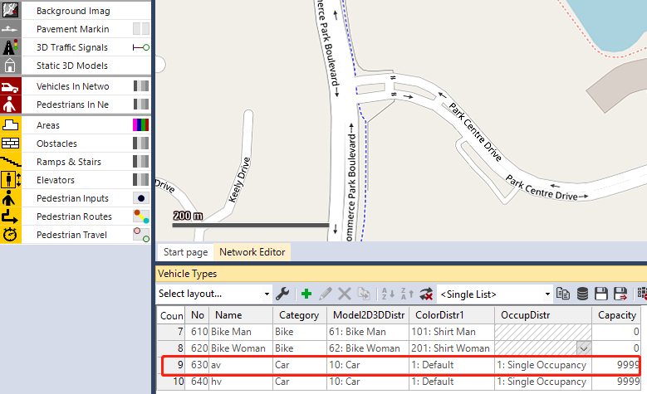

1. Click “External Driver Model” and locate the DLL generated in Step 2.

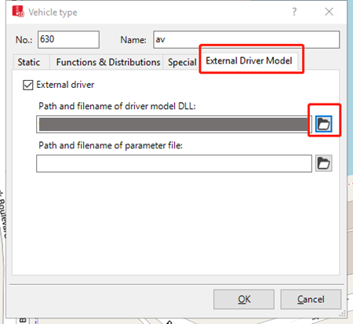

1. Right click on the HV row highlighted in red below and then click “Edit”

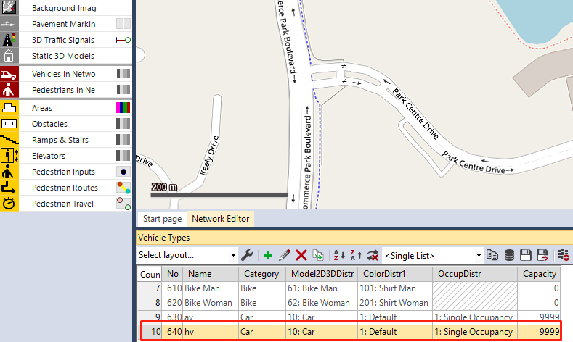

1. Click “External Driver Model” and locate the DLL generated in Step 3.

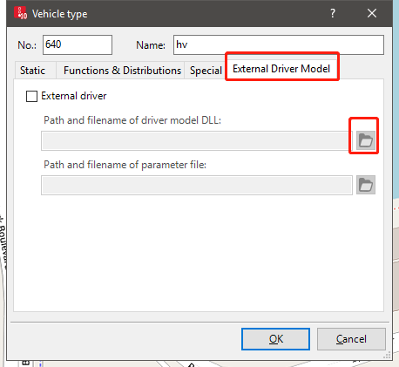

**Testing:**

1. Run the simulation in PTV VISSIM.
2. After the simulation (5 minutes), CAV and HV speed information will be generated and saved in data_put_out_AV.txt and data_put_out_HV.txt.
3. data_put_out_AV.txt preview

Every appearance of “630” represents the appearance of a new CAV.

Numbers following 630 are the CAV speeds (m/s) measured at each 0.1 second.



1. data_put_out_HV.txt preview

Every appearance of “640” represents the appearance of a new HV.

Numbers following 640 are the HV speeds (m/s) measured at each 0.1 second.



**Authors:**

Qianwen Li, Ph.D. student, Department of Civil and Environmental Engineering, University of South Florida.

Xiaopeng Li, Ph.D., Department of Civil and Environmental Engineering, University of South Florida.

**Acknowledgements:**

This research is supported by Federal Highway Administration (FHWA) Office of Operations Research and Development HRDO program under the project entitled Developing Analysis, Modeling, and Simulation (AMS) Tools for Connected Automated Vehicle Applications (Project Number: DTFH61-12-D-00030-0022).